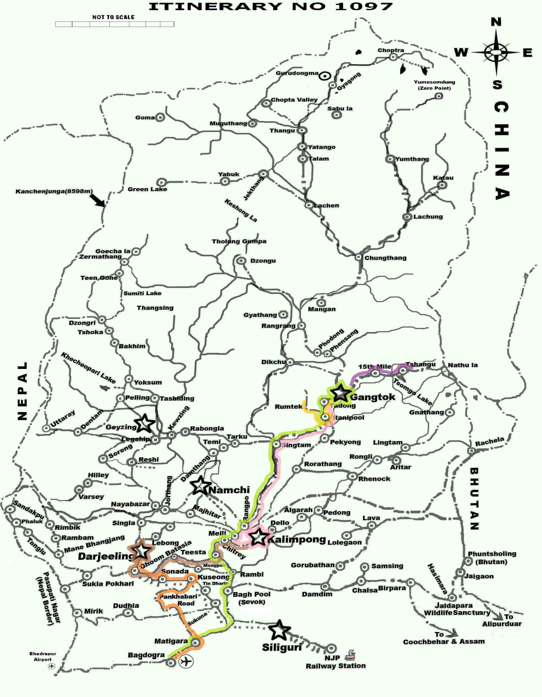

**DAY 01 DAY 02 DAY 03 DAY 04 DAY 05 DAY 07**

**ITINERARY NO.-1097**

**ITINERARY 06 NIGHTS / 07 DAYS**

**NJP RAILWAY STATION / (IXB) BAGDOGRA AIRPORT- GANGTOK (03 NIGHTS) - KALIMPONG (01 NIGHT) - DARJEELING (02 NIGHTS) - NJP RAILWAY STATION/ (IXB) BAGDOGRA AIRPORT**

**DAY 01 ARRIVAL NJP STATION / (IXB) BAGDOGRA AIRPORT - GANGTOK**

On arrival at NJP Railway Station / (IXB) , (413 Ft / 126 Mts) you will meet by our local representative who will assist you to board your vehicle to Gangtok (5412 Ft / 1650 Mts, 130 Kms / 04 to 05 Hrs), Overnight at Hotel.HH

**DAY 02 GANGTOK**

Go for a full day sightseeing covering Rumtek Monastery, Jhakri Water Fall, Do-rul Chhorten, Research Institute of Tibetology (Closed on Sunday), Directorate of Handicraft & Handloom (Closed on Sunday) and Flower Show. Overnight at Hotel.

**DAY 03    GANGTOK – TSHANGU LAKE AND BABA MANDIR EXCURSION**

*NRI, OCI, PIO Card holder & Foreign National are not allowed to visit Baba Mandir & Nathula Pass. They are allowed to visit till Tshangu Lake, with a valid permit. They also have to be 02 & above is number to visit Tshangu Lake. For getting the valid permit these guest will have to bring with them their valid passport & visa / OCI / PIO Card. They will also be required to bring along with them 08 passport size photograph for processing their permits into Sikkim, Tshangu lake, Lachen & Lachung. There will be an additional cost for processing the permit & making the tour applicable. Kindly write to us for additional cost.*

*For Indian Passport Holders to process the permit we would require the following:*

* 1. 03 passport size photograph of each member traveling whether Adult or Children with their name, age & gender written behind each photograph.
  2. Photo Copy of Photo ID proof of each member traveling whether Adult or Children. Original to be brought with self.
  3. A list mentioning the Name Age & Gender of all traveler family wise.
  4. Any documents issued by Central or State Government having Photo, Name and the address will be considered as ID Proof. The Photo ID Proof can be anyone of the following, Driving License, Voter Card, Valid Passport & Aadhar Card. Pan Card is not accepted as ID proof by the authorities.
  5. In case of Child traveling below 18 Years or couple traveling where there is no ID proof of wife, there has to be a written declaration given from the parents / husband.

*For Tshangu Lake & Nathula Pass there is no refund, after the permit is confirmed by Sikkim tourism, due to whatsoever reason (Land slide, Heavy rain fall, VIP Movement, Health issue etc).*

After breakfast, in the morning, start for excursion to **Tshangu** **Lake (12400Ft / 3780 Mts / 43Kms in 3Hrs** *one way from Gangtok***) & Baba Mandir (13100Ft / 3994 Mts / 16Kms in 1Hrs** *one way from Tshangu Lake.* Situated at a height of 12400Ft / 3780 Mts / 43Kms in 3Hrs one way, with an average depth of 50 ft. The cool water of the Lake is perfectly attuned with the scenic beauty around. Back to Gangtok and Overnight at Hotel. *(Incase of Landslide or due to any other reasons if Tshangu Lake is closed then an alternate sightseeing will be provided)*

**OPTIONAL NATHULA**

One can opt for ***Nathula Excursion by paying a supplement cost*** which varies from month to month. Organising the permit at the last moment is not possible & a clear window of 72 Hrs with proper documents is required to process the permit. Nathula permit gets confirmed a **day prior OR on the day of journey** (depending on the working of the permit issuing office) & *it is subjected to permit availability as it is allotted as per turn. At times the demend for Nathula permit goes to 700 vehicle where as the permit issued is only 60 for civil & 40 for government.* *Nathula is closed on Monday & Tuesday for tourist.*

**NATHULA CAN BE GUARANTEED IF YOU HAVE CONTACTS IN THE ARMY OR IF YOU ARE GOVERNMENT EMPLOYEE. KINDLY USE YOUR SOURCES SO THAT THE PERMIT COULD BE PROCURE. THE MODUS OPERANDI FOR THIS WOULD BE THAT YOU WOULD BE REQUIRING THE CAR NUMBER AND DRIVER LICENSE A DAY PRIOR TO THE JOURNEY DATE. INCASE YOU TAKE THE NUMBER AND DRIVER DETAILS IN ADVANCE AND GOD FORBID DUE TO WHATSOEVER REASON IF THE DRIVER AND THE VEHICLE ANY ONE OF TWO IS NOT ABLE TO REPORT THEN YOUR WHOLE EXERCISE OF GETTING THE PERMIT DONE GETS FUTILE. WHILE COORDINATING THIS WITH THE ARMY OR OTHER SOURCE, PLEASE REQUEST THE SOURCE TO DO BOTH THE ARMY AND THE TOURISM PERMISSION, THIS SAVES A LOT OF TIME.**

**WORSE TO WORSE IF ALL ABOVE GOES IN VAIN PLEASE DO NOT GET DISHEARTENED AS YOU WILL ONLY MISS 4 KM DRIVE AS THE VISIT TO THANGU LAKE & BABAMANDIR TAKES YOU INTO THE AREA WHERE NATHULA IS LOCATED.**

**Nathula(14140 Ft / 4310 Mts / 20 Kms in 1Hrs** *one way from Tshangu Lake***) Baba Mandir (13100Ft / 3994 Mts / 16Kms in 1Hrs** *one way from Tshangu Lake***)** is an Indo China border, controlled by the Indian Army & is situated approx 20 Kms ahead of Tshangu Lake at an height of 14140 Ft / 4310. The journey to Nathula & Baba Mandir is same up to 16 Kms. At this point the right arm of the “V” which is 4 Kms takes one to Baba Mandir & left arm of the “V” which is 4 Kms takes one to Nathula.

**DAY 04    GANGTOK - KALIMPONG**

After breakfast transfer to Kalimpong (4091 Ft / 1247 Mts, 85 Kms / 03 to 04 Hrs) Check in & over night at Hotel.

**DAY 05    KALIMPONG - DARJEELING**

Today after Breakfast visit Dello hills, Dr. Graham’s Home, Flower Nurseries, Jang-Dong-Palriffo Brang and Durbin Dara Hills. Transfer to Darjeeling (6710 Ft / 2046 Mts, 70 Kms / 03 to 04 Hrs) Overnight at Hotel.

**DAY 06    DARJEELING**

Early morning tour to Tiger Hills (8482 Ft / 2586 Mts at around 4 AM) to view sunrise over Kanchendzonga Peak (subject to clear weather). On way back visit Ghoom Monastery, Batasia Loop. After breakfast go for a half-day sight seeing of Japanese Temple, Peace pagoda, Padmaja Naidu Himalayan Zoological Park & Himalayan Mountaineering Institute (Closed on Thursday), Darjeeling Ropeway Ride (Ticket cost not included & will be approx INR 180.00 per person) Tenzing & Gombu Rock, Tibetan Refugee Self-Help Center (Closed on Sunday) & panoramic view of Tea Estate. Overnight at Hotel.

**DAY 07    DARJEELING - NJP RAILWAY STATION / (IXB) BAGDOGRA AIRPORT**

Transfer to NJP Railway Station / (IXB) Bagdogra Airport (413 Ft / 126 Mts, 100 Kms / 03 to 04 Hrs) for your onward connection.

**Optional via Mirik - *Drive via Mirik can be availed by paying a supplement cost of INR 1000.00 per vehicle.***

ALL THE MENTIONED RATES ARE **NETT & NON -COMMISSIONABLE** PER PERSON ON TWIN SHARING, IN INDIAN RUPEE (INR) & VALID FOR INDIAN PASSPORT HOLDERS, TRAVELING BETWEEN

**01st DECEMBER 2016** TILL **31st MARCH 2017**

**(EXCEPT FOR TRAVEL IN-BETWEEN 20th DECEMBER 2016 to 05th JANUARY 2017)**

|  |  |  |
| --- | --- | --- |
| **BRACKET / PER PERSON RATE** | **GRADE A2+ (MAPAI)** | **GRADE A1+ (MAPAI)** |
|
| 2 PAX | 42400 | 31900 |
| 4 PAX | 36800 | 26300 |
| 6 PAX | 35000 | 24500 |
| SGL ROOM RATE (SRR) | 65500 | 42900 |
| EXTRA PERSON (EPSR) | 23800 | 13200 |
| ADULT MAP SUPP | INCLUDED | INCLUDED |
| ADULT AP SUPP | 7000 | 2900 |
| CHILD WITH BED (CWB) | 16800 | 11100 |
| CHILD NO BED (CNB) | 13400 | 8400 |
| CHILD MAP SUPP | INCLUDED | INCLUDED |
| CHILD AP SUPP | 7000 | 2900 |

(*The above Rates are per person & in Indian Rupees (INR) valid for Indian Passport Holder only)*

|  |  |  |
| --- | --- | --- |
| **BRACKET / PER PERSON RATE** | **GRADE A (MAPAI)** | **GRADE B4+ (MAPAI)** |
|
| 2 PAX | 29700 | 25300 |
| 4 PAX | 24100 | 19800 |
| 6 PAX | 22200 | 17900 |
| SGL ROOM RATE (SRR) | 38700 | 28500 |
| EXTRA PERSON (EPSR) | 12300 | 10600 |
| ADULT MAP SUPP | INCLUDED | INCLUDED |
| ADULT AP SUPP | 2900 | 3400 |
| CHILD WITH BED (CWB) | 10200 | 7800 |
| CHILD NO BED (CNB) | 8200 | 6100 |
| CHILD MAP SUPP | INCLUDED | INCLUDED |
| CHILD AP SUPP | 2900 | 2600 |

(*The above Rates are per person & in Indian Rupees (INR) valid for Indian Passport Holder only)*

|  |  |  |
| --- | --- | --- |
| **BRACKET / PER PERSON RATE** | **GRADE B3+ (MAPAI)** | **GRADE B2+ (CPAI)** |
|
| 2 PAX | 23100 | 20000 |
| 4 PAX | 17500 | 14400 |
| 6 PAX | 15700 | 12600 |
| SGL ROOM RATE (SRR) | 23700 | 18300 |
| EXTRA PERSON (EPSR) | 8700 | 6900 |
| ADULT MAP SUPP | INCLUDED | 2300 |
| ADULT AP SUPP | 2800 | 4600 |
| CHILD WITH BED (CWB) | 8000 | 5900 |
| CHILD NO BED (CNB) | 4600 | 4000 |
| CHILD MAP SUPP | INCLUDED | 2300 |
| CHILD AP SUPP | 2100 | 4600 |

(*The above Rates are per person & in Indian Rupees (INR) valid for Indian Passport Holder only)*

|  |  |  |
| --- | --- | --- |
| **BRACKET / PER PERSON RATE** | **GRADE B1+ (CPAI)** | **GRADE B (CPAI)** |
|
| 2 PAX | 18900 | 16900 |
| 4 PAX | 13300 | 11300 |
| 6 PAX | 11400 | 9500 |
| SGL ROOM RATE (SRR) | 15600 | 11300 |
| EXTRA PERSON (EPSR) | 5600 | 5100 |
| ADULT MAP SUPP | 1900 | 1900 |
| ADULT AP SUPP | 3800 | 3700 |
| CHILD WITH BED (CWB) | 4400 | 4300 |
| CHILD NO BED (CNB) | 2400 | 1800 |
| CHILD MAP SUPP | 1900 | 1900 |
| CHILD AP SUPP | 3800 | 3700 |

(*The above Rates are per person & in Indian Rupees (INR) valid for Indian Passport Holder only)*

|  |  |  |
| --- | --- | --- |
| **BRACKET / PER PERSON RATE** | **GRADE C (CPAI)** | **GRADE D (CPAI)** |
|
| 2 PAX | 16300 | 15500 |
| 4 PAX | 10700 | 9900 |
| 6 PAX | 8900 | 8000 |
| SGL ROOM RATE (SRR) | 10300 | 7600 |
| EXTRA PERSON (EPSR) | 3200 | 2900 |
| ADULT MAP SUPP | 1700 | 1600 |
| ADULT AP SUPP | 3400 | 2900 |
| CHILD WITH BED (CWB) | 2800 | 2500 |
| CHILD NO BED (CNB) | 1700 | 1300 |
| CHILD MAP SUPP | 1600 | 1400 |
| CHILD AP SUPP | 3100 | 2900 |

(*The above Rates are per person & in Indian Rupees (INR) valid for Indian Passport Holder only)*

|  |  |
| --- | --- |
| **SUPPLEMENT COST FOR ADDITIONAL VEHICLE** |  |
| 2nd Luxury Vehicle (Scorpio / Xylo) for the above Itinerary | 22300 |

|  |  |  |
| --- | --- | --- |
| **GRADE** | **GRADE A2+ (MAPAI)** | **GRADE A1+ (MAPAI)** |
| GANGTOK | MAYFAIR RESORT & SPA (DELUXE) | DENZONG REGENCY (SUIT) / HOTEL NORKHILL (DELUXE) |
| KALIMPONG | SILVER OAKS (DELUXE) | SILVER OAKS (DELUXE) |
| DARJEELING | MAYFAIR HILL RESORT (DELUXE) | HOTEL NEW ELGIN (DELUXE) |

|  |  |  |
| --- | --- | --- |
| **GRADE** | **GRADE A (MAPAI)** | **GRADE B4+ (MAPAI)** |
| GANGTOK | ROYAL PLAZA (CLUB ROOM) | ORANGE VILLAGE RESORT (LUXURY) |
| KALIMPONG | SILVER OAKS (DELUXE) | SILVER OAKS (DELUXE) |
| DARJEELING | HOTEL VICEROY (ATTIC) | HOTEL VICEROY (EXECUTIVE) |

|  |  |  |
| --- | --- | --- |
| **GRADE** | **GRADE B3+ (MAPAI)** | **GRADE B2+ (CPAI)** |
| GANGTOK | KEEPSA RESIDENCY (DELUXE) | VICEROY LE PRIMULA (EXECUTIVE) / ROYAL OAKS (EXECUTIVE) / MAPPLE RESIDENCY (EXECUTIVE) |
| KALIMPONG | ANAND PORTICO (DELUXE) | ANAND PORTICO (DELUXE) |
| DARJEELING | SIAN RESORT & SPA (DELUXE) | STERLING RESORT (CLASSIC) |

|  |  |  |
| --- | --- | --- |
| **GRADE** | **GRADE B1+ (CPAI)** | **GRADE B (CPAI)** |
| GANGTOK | CHUMBI RESIDENCY (ROSE) / TEMI HOUSE (DELUXE) | TASHI PALACE - VEG (DELUXE) / HIMALAYAN HEIGHTS (SUP DLX) |
| KALIMPONG | SOODS GARDEN RETREAT (DELUXE) | SOODS GARDEN RETREAT (DELUXE) |
| DARJEELING | VILLA EVEREST (DELUXE) / PINK MOUNTAIN (SIGNATURE) | HOTEL JAGJEET YUMA (LUXURY) |

|  |  |  |
| --- | --- | --- |
| **GRADE** | **GRADE C (CPAI)** | **GRADE D (CPAI)** |
| GANGTOK | SIKKIM RETREAT (LUXURY) / DEWACHEN RETREAT (LUXURY) / HOTEL CINERARIA (DELUXE) | COMFORT INN (DELUXE) |
| KALIMPONG | HOTEL MOUNTAIN VIEW (DELUXE) | HOTEL MOUNTAIN VIEW (DELUXE) |
| DARJEELING | HOTEL JAGJEET YUMA (LUXURY) | HOTEL NORTH STAR (DELUXE) |

**ABOUT THE HOTELS:-**

We have used hotels which are not to be compared with the Hotels of other developed destinations. We have selected, combined & graded the hotels in a fashion, so that the Guest gets similar kind of standard in services & facilities at every destination / place of retirement. For the easy understanding we have termed

* 1. GRADE A2+ - ‘The Area’s First Best Hotels’ whose services are similar to a Four Star+ hotel (Other than Lachen & Lachung).
  2. GRADE A1+ & GRADE A - ‘The Area’s Second Best Hotels’ whose services are close to a Four Star / Three Star+ Hotel (Other than Lachen & Lachung).
  3. GRADE B4+, B3+, B2+, B1+ - ‘The Area’s Third Best Hotels’ whose services are similar to a Three Star Hotel (Other than Lachen & Lachung).
  4. GRADE B & C - ‘The Area’s Fourth Best Hotels’ whose services are similar to a Two Star Hotel (Other than Lachen & Lachung).
  5. GRADE D – ‘The Area’s Fifth Best Hotels’ whose services are similar to a Budget & Tourist Class Hotel.

*Hotels that are located in the remote areas like Lachen, Lachung, Yuksom, Mirik etc where they don’t have higher categories hotel option there we use areas best property.*

*During Winters Grade B4+ and above category hotels provide complimentary Heaters. Hotels in Grade B3+ and below provide Heaters on Additional Cost which varies from INR 300.00 to INR 500.00 per heater per night from hotel to hotel. Few of the hotels among Grade B3+ & below do provide complimentary heaters on request.*

**ABOUT THE TRANSPORT:-**

1. The above package is done on AC Luxury Vehicle (Scorpio / Xylo). This Luxury Vehicle (Scorpio / Xylo) will be provided to the guest for the complete tour.
2. The vehicle changes every day/Sector wise & will be on contract as per the itinerary. This vehicle is not on disposal.
3. Also while travelling in Luxury Vehicle please inform the guest to travel light with minimum baggage of one piece per person.  In case of excess baggage the guest will have to opt for an extra vehicle for carrying the excess baggage. The cost for this will be collected directly from the guest.
4. Maximum 06 Heads (Including adult & children) will be allowed in a Luxury vehicle. AC of this luxury vehicle will only operate in plain & not in hills.
5. ***Incase if the guest wants specific Innova only (on Disposal from 0900 Hrs to 1800 Hrs within city limit with maximum running of 120 Kms) then there will be an additional cost of INR 800.00 per day on and above the cost of Luxury Vehicle. We strongly recommend this up gradation, especially for those guests who are opting to travel on GRADE B and above hotels.***

**COST BASED ON (valid for Indian National only)**

* Twin Sharing Per Person
* Extra Person / Child With Bed (CWB) sharing the Room on mattress
* All Transfer & Sightseeing by 01 Luxury Vehicle (Scorpio / Xylo)
* Meal Plan as per the details mentioned in the Hotel Bracket in **BLUE.**
* All applicable Transfers & Sightseeing by Specified vehicle which will not be at disposal and will be exclusively used for the guest as per the itinerary only (on point to point basis). This vehicle will also change sector wise.

***THE COST INCLUDES***

* Meet & Greet upon arrival at Airport / NJP Station
* Hotel Accommodation as per the name mentioned in the Category for duration as mentioned in the itinerary.
* All applicable Transfers & Sightseeing by Specified vehicle which will not be at disposal and will be exclusively used for the guest as per the itinerary only (on point to point basis). This vehicle will also change sector wise.

***THE COST DOES NOT INCLUDE***

* **Government Service Tax as applicable (as on date 01/06/2016 it is 4.50%)**
* Cost for supplementary service, optional Tours, Up-gradation Charges, Guide, Sightseeing entrance fees.
* Cost for Airfare, Train fare, Insurance Premiums, Rafting Charges.
* Cost for service provided on a personal request.
* ***Heater Charges.***
* Cost for personal expenses such as laundry, bottled water, soft drinks, incidentals, porter charges, tips etc.
* Cost for any other service not mentioned under the “Cost Includes” head.
* Difference in cost arising due to change in Taxes by the Government which will have to be collected directly ON ARRIVAL.
* Difference in cost arising due to change in Fuel price (Calculation based on Petrol INR 69 per liter & Diesel INR 50 per liter)
* Difference in cost arising due to extra usage of vehicle, other than scheduled & mentioned in the itinerary.
* Difference in cost arising due to mishaps, political unrest, natural calamities like - landslides, road blockage, etc. In such case extra will have to be paid on the spot by the guest directly.

**Supplement for ONESIDE Pickup OR Drop to/from Darjeeling/Kalimpong/Gangtok will be as follows-**

|  |  |  |
| --- | --- | --- |
| **PICK UP OR DROP From DRJ / GTK / KPG** | **Nac Indica / Tata Sumo** | **Luxury Vehicle (Scorpio / Xylo)** |
| To Phuntsholing (Bhutan Border) | INR 3000.00 per vehicle | INR 4500.00 per vehicle |
| To Bhadrapur (Nepali Airport) | INR 3000.00 per vehicle | INR 4500.00 per vehicle |

***THE FOLLOWING POINTS ARE TO BE NOTED FOR CHILD RATE***

* Children above 10+ years will be charged 100% as per Adult Rate (EPSR)
* Children of 5+ to 10 sharing parent’s room will be charged as per CWB or CNB
* Children below 5 years Complimentary

*(Hotels are very strict with the child policy. Please carry the age proof so that it can be produced when asked for)*

|  |
| --- |
| **FOR FURTHER INFORMATION PLEASE CLICK ON THE BELOW** |
| [**IMPORTANT NOTE ON TRAVELLERS TRAVELLING TO SIKKIM & DARJEELING**](http://heatflexiholidays.com/FWO/FWO-IMPORTANT-NOTE.doc) |
| [**SCHEDULE & TIMING FOR DAILY VEHICLE REPORTING**](http://heatflexiholidays.com/FWO/FWO-SCHEDULE-TIMING-FOR-DAILY-VECHILE-REPORTING.pdf) |
| [**BOOKING, PAYMENT PROCEDURE & AMENDED / CANCELLATION**](http://heatflexiholidays.com/FWO/FWO-BOOKING-PROCEDURE.doc) |